  Make: |  |  | Plate /plant No: |  |  |  |  | Date: From / / 2024 To / / 2024
ROUGH TERRAIN | CRAWLER LATTICE BOOM |  |  |  |  |  | ALL TERRAIN | CRAWLER TELESCOPIC |  |  |  |  |  | SPIDER CRANE | LORRY MOUNTED CRANE
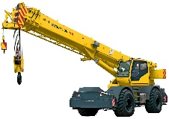 | 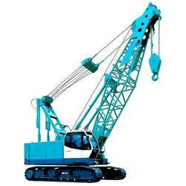 |  |  |  |  |  | 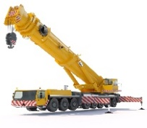 | 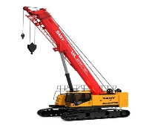 |  |  |  |  |  | 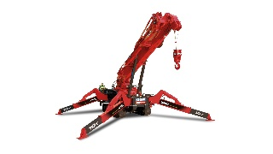 | 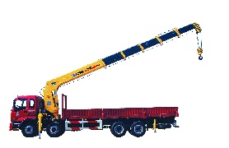
Items | Days |  |  | Day | Night | Items |  |  | days | Day |  | Night | Items |  |  | Days | Day | Night
 Documents | Sun |  |  |  |  | 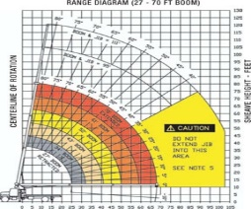 Load Chart |  |  | Sun |  |  |  |   Crane Manual |  |  | Sun
 | Mon |  |  |  |  |  |  |  | Mon |  |  |  |  |  |  | Mon
 | Tue |  |  |  |  |  |  |  | Tue |  |  |  |  |  |  | Tue
 | Wed |  |  |  |  |  |  |  | Wed |  |  |  |  |  |  | Wed
 | Thu |  |  |  |  |  |  |  | Thu |  |  |  |  |  |  | Thu
 | Fri |  |  |  |  |  |  |  | Fri |  |  |  |  |  |  | Fri
 | Sat |  |  |  |  |  |  |  | Sat |  |  |  |  |  |  | Sat
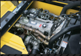Engine Condition | Sun |  |  |  |  | 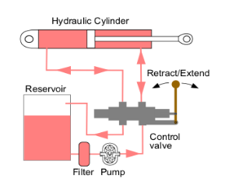Hydraulic System |  |  | Sun |  |  |  | 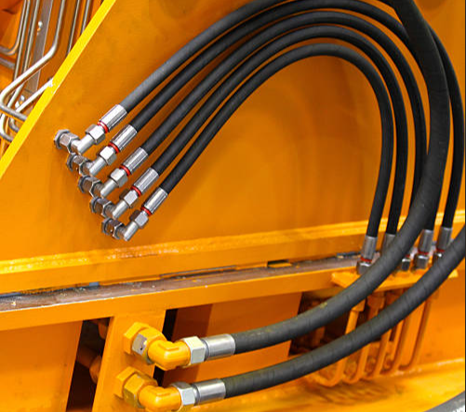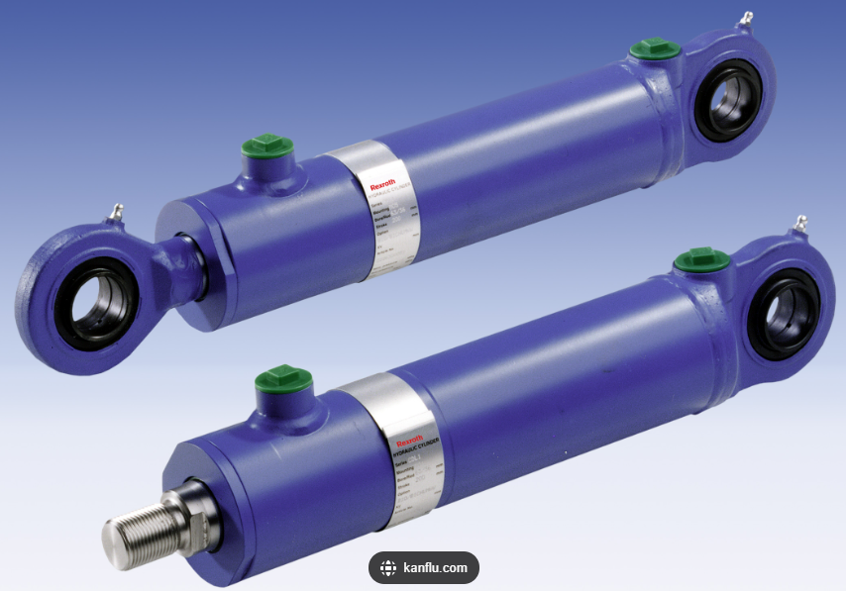  Hydraulic Hoses / Cylinder Condition |  |  | Sun
 | Mon |  |  |  |  |  |  |  | Mon |  |  |  |  |  |  | Mon
 | Tue |  |  |  |  |  |  |  | Tue |  |  |  |  |  |  | Tue
 | Wed |  |  |  |  |  |  |  | Wed |  |  |  |  |  |  | Wed
 | Thu |  |  |  |  |  |  |  | Thu |  |  |  |  |  |  | Thu
 | Fri |  |  |  |  |  |  |  | Fri |  |  |  |  |  |  | Fri
 | Sat |  |  |  |  |  |  |  | Sat |  |  |  |  |  |  | Sat
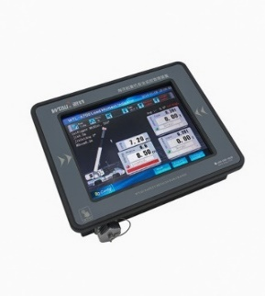Load Monitor | Sun |  |  |  |  | 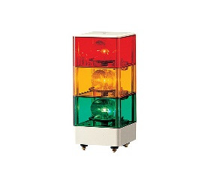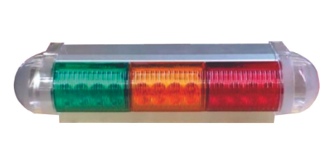  Load Indicator Light |  |  | Sun |  |  |  | 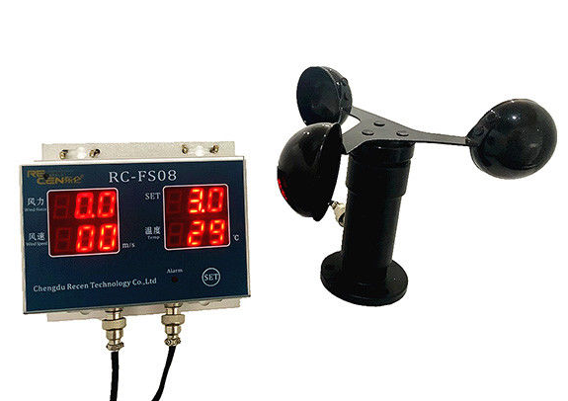  Anemometer Device |  |  | Sun
 | Mon |  |  |  |  |  |  |  | Mon |  |  |  |  |  |  | Mon
 | Tue |  |  |  |  |  |  |  | Tue |  |  |  |  |  |  | Tue
 | Wed |  |  |  |  |  |  |  | Wed |  |  |  |  |  |  | Wed
 | Thu |  |  |  |  |  |  |  | Thu |  |  |  |  |  |  | Thu
 | Fri |  |  |  |  |  |  |  | Fri |  |  |  |  |  |  | Fri
 | Sat |  |  |  |  |  |  |  | Sat |  |  |  |  |  |  | Sat
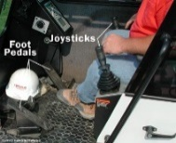  Operator Cabin | Sun |  |  |  |  |   Breaking System |  |  | Sun |  |  |  | 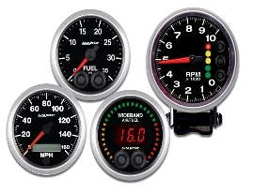  Gauges |  |  | Sun
 | Mon |  |  |  |  |  |  |  | Mon |  |  |  |  |  |  | Mon
 | Tue |  |  |  |  |  |  |  | Tue |  |  |  |  |  |  | Tue
 | Wed |  |  |  |  |  |  |  | Wed |  |  |  |  |  |  | Wed
 | Thu |  |  |  |  |  |  |  | Thu |  |  |  |  |  |  | Thu
 | Fri |  |  |  |  |  |  |  | Fri |  |  |  |  |  |  | Fri
 | Sat |  |  |  |  |  |  |  | Sat |  |  |  |  |  |  | Sat
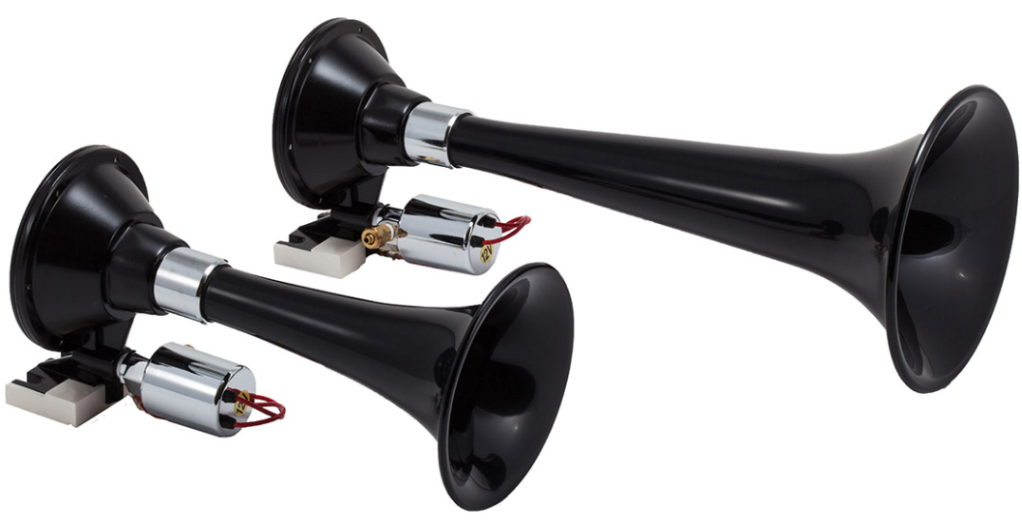 Horn system / Sheaves | Sun |  |  |  |  | 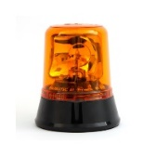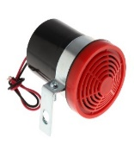Beacon / Reverse Alarm |  |  | Sun |  |  |  | 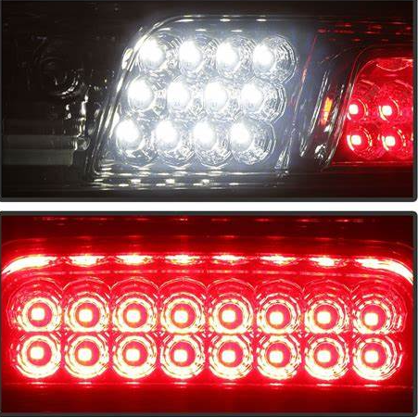  Head & Rear light |  |  | Sun
 | Mon |  |  |  |  |  |  |  | Mon |  |  |  |  |  |  | Mon
 | Tue |  |  |  |  |  |  |  | Tue |  |  |  |  |  |  | Tue
 | Wed |  |  |  |  |  |  |  | Wed |  |  |  |  |  |  | Wed
 | Thu |  |  |  |  |  |  |  | Thu |  |  |  |  |  |  | Thu
 | Fri |  |  |  |  |  |  |  | Fri |  |  |  |  |  |  | Fri
 | Sat |  |  |  |  |  |  |  | Sat |  |  |  |  |  |  | Sat
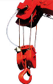  Hook Block & safety Latch | Sun |  |  |  |  | 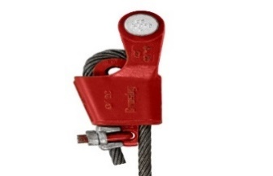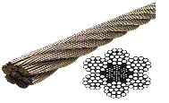  Wedge Socket & Wire Rope |  |  | Sun |  |  |  | 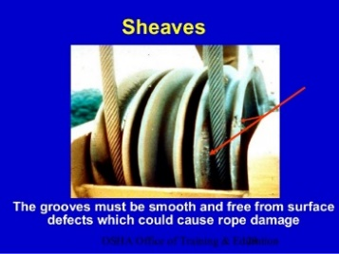  Sheaves |  |  | Sun
 | Mon |  |  |  |  |  |  |  | Mon |  |  |  |  |  |  | Mon
 | Tue |  |  |  |  |  |  |  | Tue |  |  |  |  |  |  | Tue
 | Wed |  |  |  |  |  |  |  | Wed |  |  |  |  |  |  | Wed
 | Thu |  |  |  |  |  |  |  | Thu |  |  |  |  |  |  | Thu
 | Fri |  |  |  |  |  |  |  | Fri |  |  |  |  |  |  | Fri
 | Sat |  |  |  |  |  |  |  | Sat |  |  |  |  |  |  | Sat
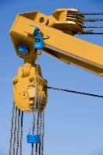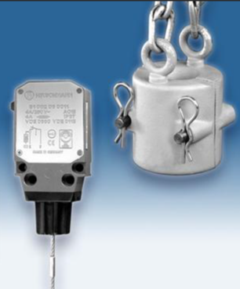  Anti-Two Block Devices | Sun |  |  |  |  | 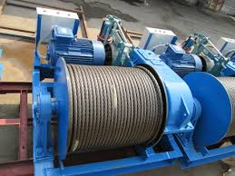  Winch & Spooling |  |  | Sun |  |  |  | 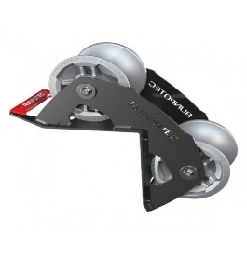  Wire Rope Guide Roller |  |  | Sun
 | Mon |  |  |  |  |  |  |  | Mon |  |  |  |  |  |  | Mon
 | Tue |  |  |  |  |  |  |  | Tue |  |  |  |  |  |  | Tue
 | Wed |  |  |  |  |  |  |  | Wed |  |  |  |  |  |  | Wed
 | Thu |  |  |  |  |  |  |  | Thu |  |  |  |  |  |  | Thu
 | Fri |  |  |  |  |  |  |  | Fri |  |  |  |  |  |  | Fri
 | Sat |  |  |  |  |  |  |  | Sat |  |  |  |  |  |  | Sat
ROUGH TERRAIN | CRAWLER LATTICE BOOM |  |  |  |  |  | ALL TERRAIN | CRAWLER TELESCOPIC |  |  |  |  |  | SPIDER CRANE | LORRY MOUNTED CRANE
 |  |  |  |  |  |  | 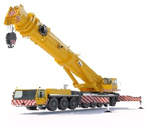 |  |  |  |  |  |  |  | 
Items | Days |  |  | Day | Night | Items |  |  | days | Day |  | Night | Items |  |  | Days | Day | Night
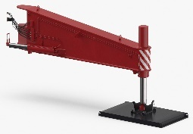  Outrigger Jack | Sun |  |  |  |  | 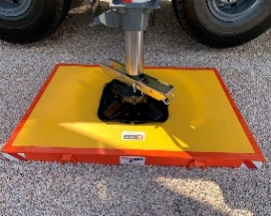  Outrigger Pad / Mat |  |  | Sun |  |  |  | 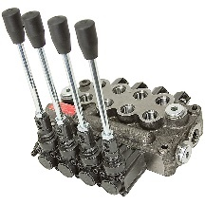Outriggers Control System |  |  | Sun
 | Mon |  |  |  |  |  |  |  | Mon |  |  |  |  |  |  | Mon
 | Tue |  |  |  |  |  |  |  | Tue |  |  |  |  |  |  | Tue
 | Wed |  |  |  |  |  |  |  | Wed |  |  |  |  |  |  | Wed
 | Thu |  |  |  |  |  |  |  | Thu |  |  |  |  |  |  | Thu
 | Fri |  |  |  |  |  |  |  | Fri |  |  |  |  |  |  | Fri
 | Sat |  |  |  |  |  |  |  | Sat |  |  |  |  |  |  | Sat
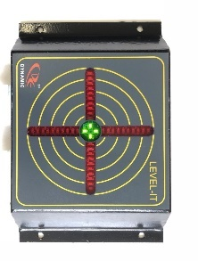  Level Indicator | Sun |  |  |  |  | 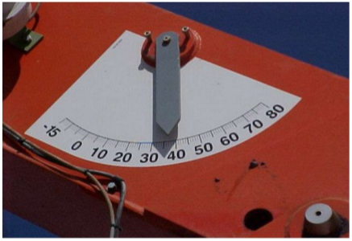  Boom Angle Indicator |  |  | Sun |  |  |  | 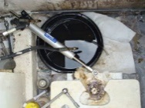  Oil Leak |  |  | Sun
 | Mon |  |  |  |  |  |  |  | Mon |  |  |  |  |  |  | Mon
 | Tue |  |  |  |  |  |  |  | Tue |  |  |  |  |  |  | Tue
 | Wed |  |  |  |  |  |  |  | Wed |  |  |  |  |  |  | Wed
 | Thu |  |  |  |  |  |  |  | Thu |  |  |  |  |  |  | Thu
 | Fri |  |  |  |  |  |  |  | Fri |  |  |  |  |  |  | Fri
 | Sat |  |  |  |  |  |  |  | Sat |  |  |  |  |  |  | Sat
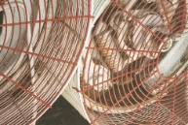  Moving Parts | Sun |  |  |  |  | 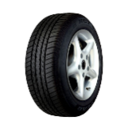  Tires |  |  | Sun |  |  |  | 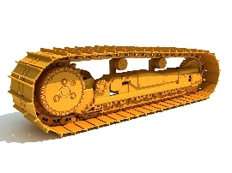  Crawler Track |  |  | Sun
 | Mon |  |  |  |  |  |  |  | Mon |  |  |  |  |  |  | Mon
 | Tue |  |  |  |  |  |  |  | Tue |  |  |  |  |  |  | Tue
 | Wed |  |  |  |  |  |  |  | Wed |  |  |  |  |  |  | Wed
 | Thu |  |  |  |  |  |  |  | Thu |  |  |  |  |  |  | Thu
 | Fri |  |  |  |  |  |  |  | Fri |  |  |  |  |  |  | Fri
 | Sat |  |  |  |  |  |  |  | Sat |  |  |  |  |  |  | Sat
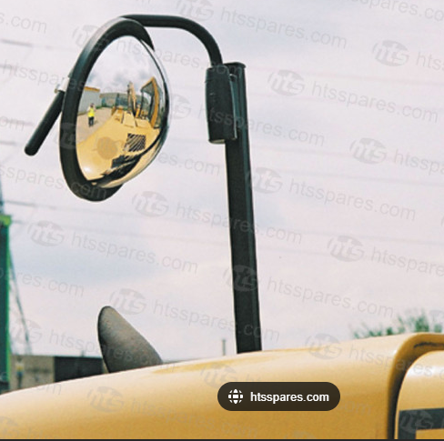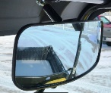  Side Mirrors | Sun |  |  |  |  | 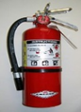  Fire Extinguisher |  |  | Sun |  |  |  | 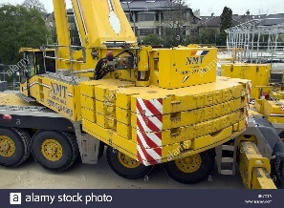  Counterweight |  |  | Sun
 | Mon |  |  |  |  |  |  |  | Mon |  |  |  |  |  |  | Mon
 | Tue |  |  |  |  |  |  |  | Tue |  |  |  |  |  |  | Tue
 | Wed |  |  |  |  |  |  |  | Wed |  |  |  |  |  |  | Wed
 | Thu |  |  |  |  |  |  |  | Thu |  |  |  |  |  |  | Thu
 | Fri |  |  |  |  |  |  |  | Fri |  |  |  |  |  |  | Fri
 | Sat |  |  |  |  |  |  |  | Sat |  |  |  |  |  |  | Sat
  Seat Belt | Sun |  |  |  |  | 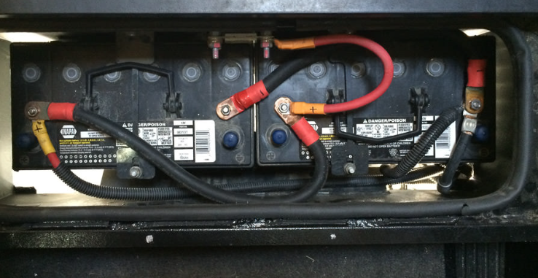  Battery Condition |  |  | Sun |  |  |  | 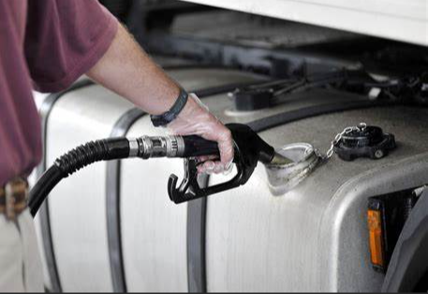  Fuel Tank |  |  | Sun
 | Mon |  |  |  |  |  |  |  | Mon |  |  |  |  |  |  | Mon
 | Tue |  |  |  |  |  |  |  | Tue |  |  |  |  |  |  | Tue
 | Wed |  |  |  |  |  |  |  | Wed |  |  |  |  |  |  | Wed
 | Thu |  |  |  |  |  |  |  | Thu |  |  |  |  |  |  | Thu
 | Fri |  |  |  |  |  |  |  | Fri |  |  |  |  |  |  | Fri
 | Sat |  |  |  |  |  |  |  | Sat |  |  |  |  |  |  | Sat
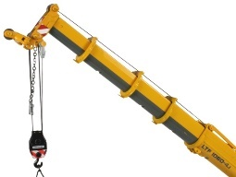  Telescopic Boom | Sun |  |  |  |  | 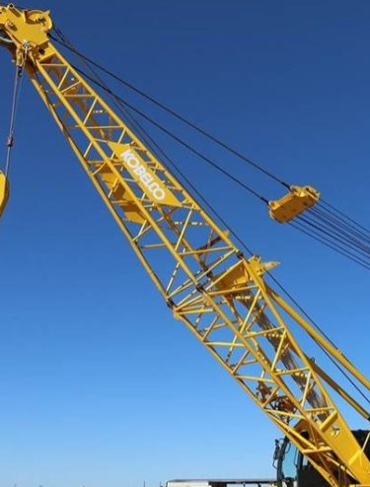  Lattice Boom |  |  | Sun |  |  |  | 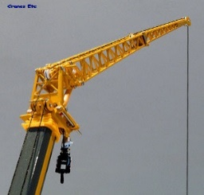  Fly Jib |  |  | Sun
 | Mon |  |  |  |  |  |  |  | Mon |  |  |  |  |  |  | Mon
 | Tue |  |  |  |  |  |  |  | Tue |  |  |  |  |  |  | Tue
 | Wed |  |  |  |  |  |  |  | Wed |  |  |  |  |  |  | Wed
 | Thu |  |  |  |  |  |  |  | Thu |  |  |  |  |  |  | Thu
 | Fri |  |  |  |  |  |  |  | Fri |  |  |  |  |  |  | Fri
 | Sat |  |  |  |  |  |  |  | Sat |  |  |  |  |  |  | Sat
REMARK:

Third Party Expiry Date: |  |  |  |  |  |  |  | Registration Expiry Date:
Inspected By Optrs. |  | Day Shift Operator |  |  |  |  |  |  |  |  | Night Shift Operator
 |  | Certificate Expiry date |  |  |  |  |  |  |  |  | Certificate Expiry Date:
 |  | Signature: |  |  |  |  |  |  |  |  | Signature:

